**PRELIMINARY INVESTIGATION**

**ORGANIZATIONAL OVERVIEW**

* Apna Punjab Catering is a catering service which provides catering for different events.
* At present customer can call or go to the store and make order according to their requirements.
* The customer can order from the menu provided or can also add their own menu item.

**DESCRIPTION OF PRESENT SYSTEM**

* Presently the store was not much known by the people and the products were not much published ,since they did not have any website for the better publication of the products.
* The present system works by placing orders via calls or manually coming to the store and placing order.
* The order of purchasing of products was done manually. Due to which a group of workers were appointed to handle the work.
* The transactions are done manually and reports are kept written in books and often after the year ends the books are discarded and new books are filled with the order details and transaction details, etc.

**LIMITATIONS OF THE PRESENT SYSTEM**

* Since,the present stores system was maintained manually and did not have any website for the publicity of the store,it use to take a lot of time and efforts of the owner as well as the staff to sell the products and make the bill for the payment. The store did not have a website to promote their products to the customers.
* The current system does not provide any online transaction.
* In the current system only, cash on delivery and cheque are available for the payment.
* Since they did not use any technology they had to maintain each and every information and record manually.

**DESCRIPTION OF THE PROPOSED SYSTEM**

* The proposed system is having the online website with the main objective of automating the present system. The website will be interactive and informative.
* Proposed to large amount of customers:

This online website has the ability to reach a large number of the audience and it also provides the necessary information about the products needed to the customers.

* Possible to maintain the whole information about the website:

It can store all the information about the store and even maintain the registration details of the online catering .

* Can solve queries of the Customers:

Can solve the queries of the customers related to the event information on the website and no need to communicate to the owner for the information.

* There will be no delay in the delivery.
* Store location can be tracked.

**LIMITATIONS OF THE PROPOSED SYSTEM**

* At present, the customer can’t order online ,customer have to book an appointment and manually go to the store and further order process is conducted.

**SYSTEM ANALYSIS**

**EVENT LIST**

**Visitor:**

The Visitor can perform the following tasks:

1. Visitor browses Home Page/Menu/Events/Contact Us /About Us.
2. Visitor wants to register.

**Customer:**

The Customer can perform the following tasks:

1. Customer browses Home Page/Menu/Events/Contact Us /About Us.
2. Customer Logs in.
3. Customer wants to book for event.
4. Customer places new order.
5. Customer requests for cancel/modify the order.
6. Customer wants to send query.
7. Customer tracks booking details.
8. Customer tracks the order details.
9. Customer wants to modify his/her details.

**Admin:**

The Admin can perform the following tasks:

1. Admin browses Home Page/Menu/Events/Contact Us /About Us.
2. Admin provide new menu item details.
3. Admin provide new event details.
4. Admin can modify bill.
5. Admin wants to view bill.
6. Admin wants to view the customer details.
7. Admin wants to view the menu details.
8. Admin wants to view the order details.
9. Admin wants to view the order summary.
10. Admin wants to view the enquiry summary.
11. Admin wants to view the cancel summary.
12. Admin wants to view the payment summary.
13. Admin responds to the query.

**EVENT TABLE**

|  |  |  |  |  |  |
| --- | --- | --- | --- | --- | --- |
| **Event** | **Trigger** | **Source** | **Activity/Use case** | **Response** | **Destination** |
| Visitor browses Home Page/Menu/Events/Contact Us /About Us | Click on the Home Page/Menu/Events/Contact Us /About Us | Visitor | Load Home Page Home Page/Menu/Events/Contact Us /About Us | Displays Home Page /Products/Feedback/Contact Us/About Us. | Visitor |
| Visitor wants to register. | New registration | Visitor | Create new registration | Registration confirmation  Registration details | Visitor  Admin |
|  |  |  |  |  |  |
| Customer browses Home Page/Menu/Events/Contact Us /About Us. | Click on the Home Page/Menu/Events/Contact Us /About Us. | Customer | Load Home Page/Menu/Events/Contact Us /About Us. | Displays Home Page/Menu/Events/Contact Us /About Us. | Customer |
| Customer Logs in. | Fill Login credentials | Customer | Record and verify Login details | Login successful | Customer |
| Customer wants to book for event. | New Booking | Customer | Create new booking | Booking confirmation  Booking details | Customer  Admin |
| Customer places new order. | New order. | Customer | Create new order. | Order Confirmation.  Order Details, | Customer  Admin |
| Customer requests for cancel/modify the order. | Request order cancellation/ modification | Customer | Update order | Updated order confirmation | Customer |
| Customer post query. | New query | Customer | Record Query Details. | Query details | Admin |
| **Event** | **Trigger** | **Source** | **Activity/Use case** | **Response** | **Destination** |
| Customer tracks booking details. | Booking status enquiry | Customer | Load Booking Status details. | Booking status details | Customer |
| Customer tracks the order details. | Order status enquiry | Customer | Load Order details | Order details | Customer |
| Customer wants to modify his/her details | Requests modification. | Customer | Update Details. | Updated customer details. | Customer |
|  |  |  |  |  |  |
| Admin browses Home Page/Products/Reviews/Feedback/Contact Us/About Us | Click on the Home Page/ Products /Reviews/ Feedback/ Contact Us/ About Us. | Admin | Load Home Page/Products/Reviews/Feedback/Contact Us/About Us | Displays Home Page/Products/Reviews/Feedback/Contact Us/About Us | Admin |
| Admin provide new menu item details. | New menu item. | Admin | Create new menu item. | Menu Item details. | Admin |
| Admin provide new event details. | New event. | Admin | Create new event. | Event details | Admin |
| Admin can modify bill. | Select bill details. | Admin | Update bill. | Updated bill details. | Admin |
| Admin wants to view bill. | Select on bill details. | Admin | Load bill details. | Display bill details | Admin |
| Admin wants to view the customer details. | Select on customer details. | Admin | Load customer details. | Display customer details. | Admin |
| Admin wants to view the menu details. | Select on menu details | Admin | Load menu details | Display menu details | Admin |
| **Event** | **Trigger** | **Source** | **Activity/Use case** | **Response** | **Destination** |
| Admin wants to view the order details | Select on order details | Admin | Load order details | Display order details | Admin |
| Admin responds to the query. | Fill response details. | Admin | Record response details | Response details. | Customer |
| Admin wants to view the order summary. | Select on order summary. | Admin | Load order summary. | Display order summary. | Admin |
| Admin wants to view the cancel summary. | Select on cancel summary. | Admin | Load cancel summary. | Display cancel summary. | Admin |
| Admin wants to view the payment summary. | Select on payment summary. | Admin | Load payment summary. | Display payment summary. | Admin |

**Class Diagram**

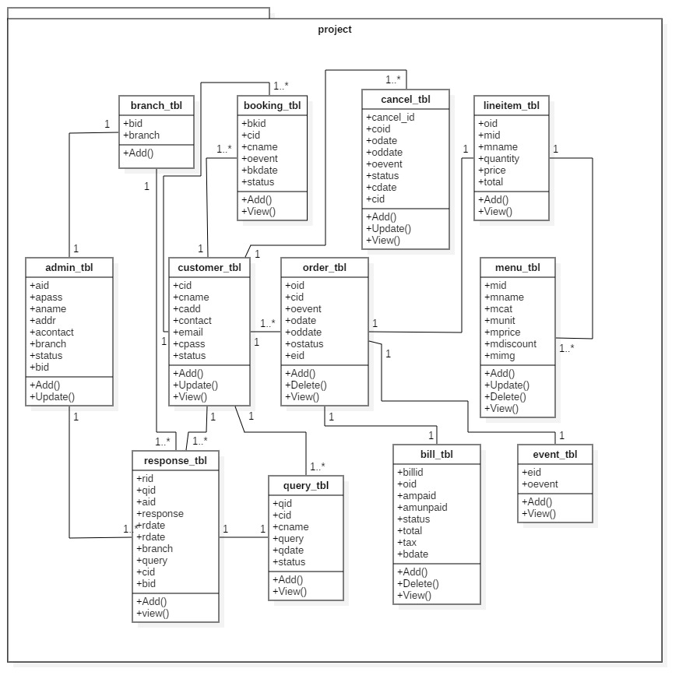

**Use Case**

**Visitor:**

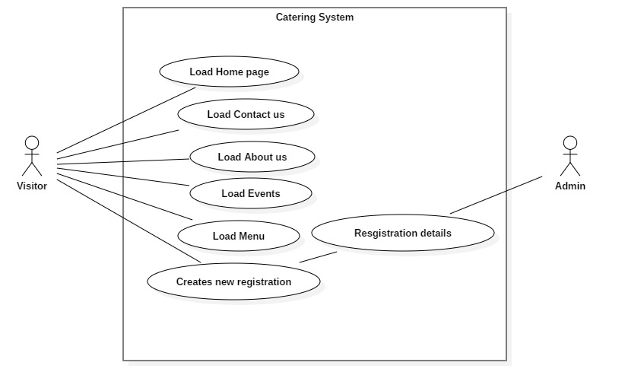

**Customer:**

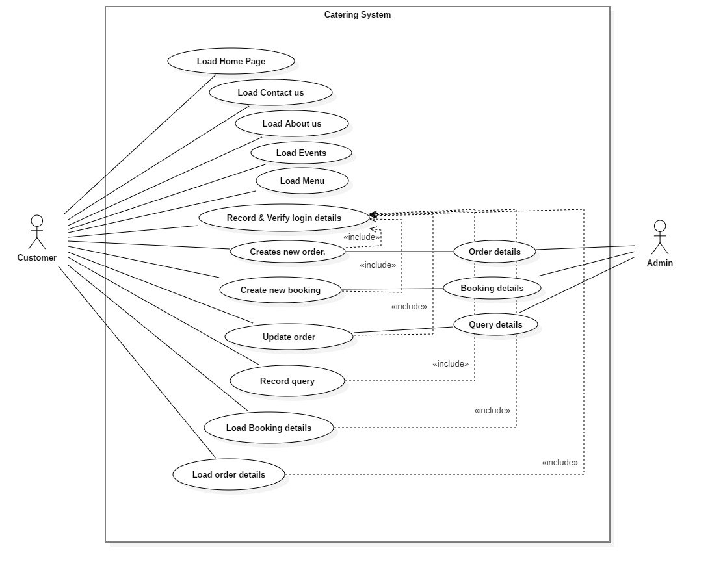

**Admin:**

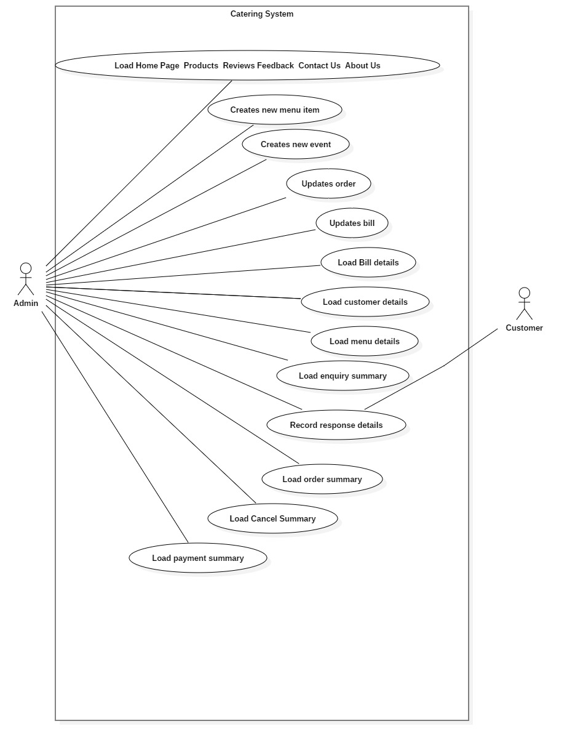

**Sequence Diagram**

**Visitor:**

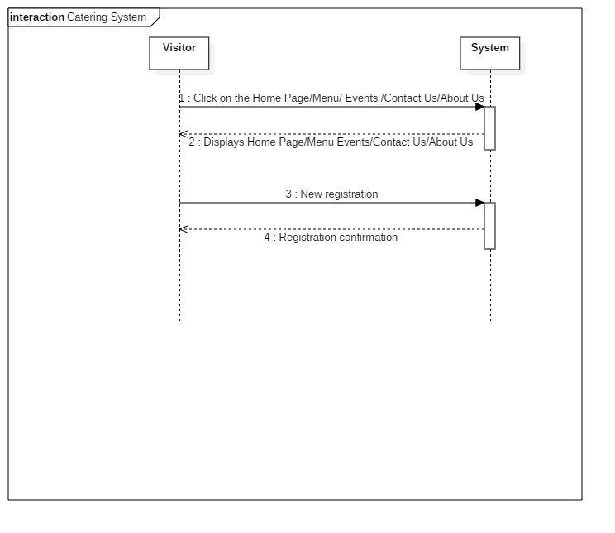

**Customer:**

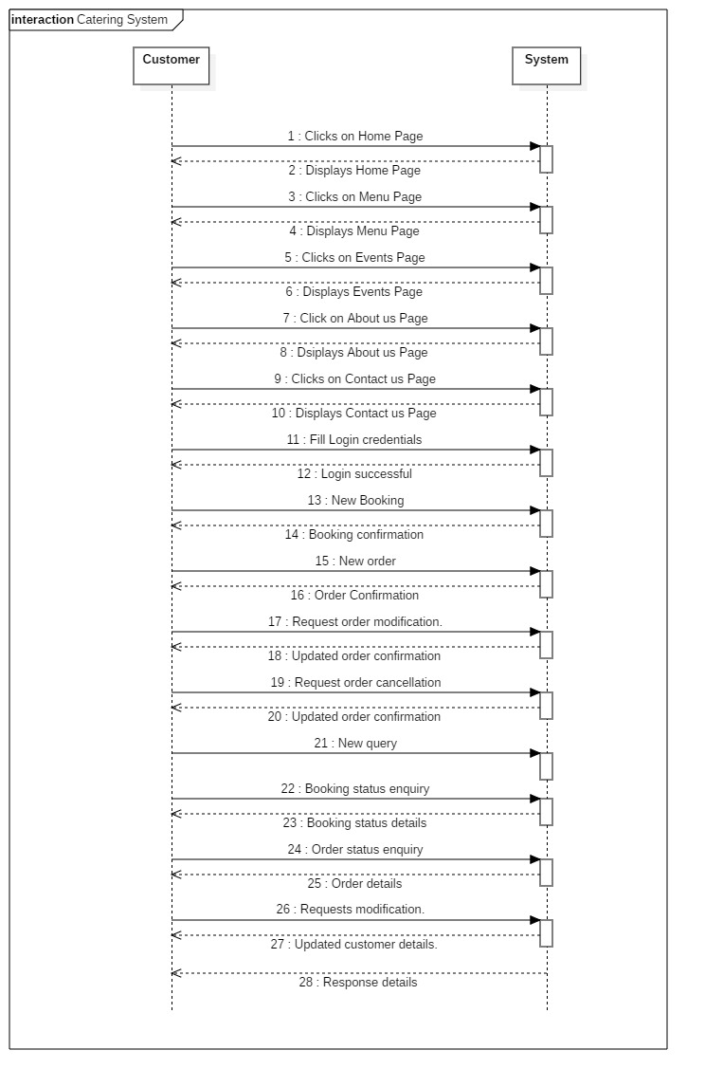

**Admin:**

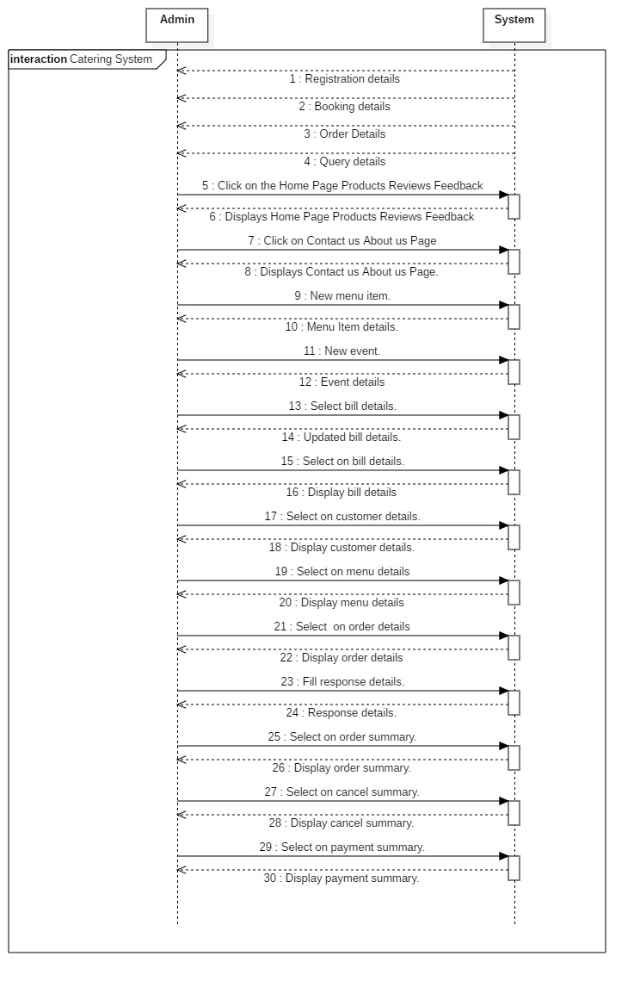

**Object Diagram**

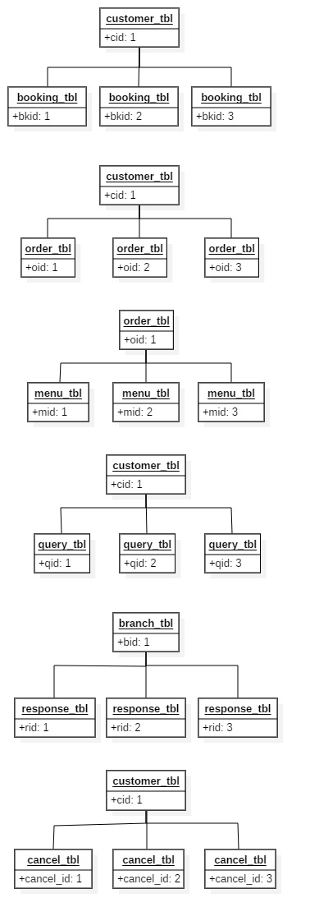

**State Diagram**

**Visitor:**

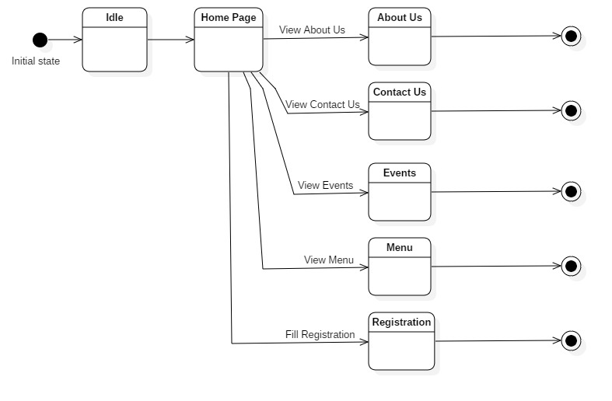

**Customer:**

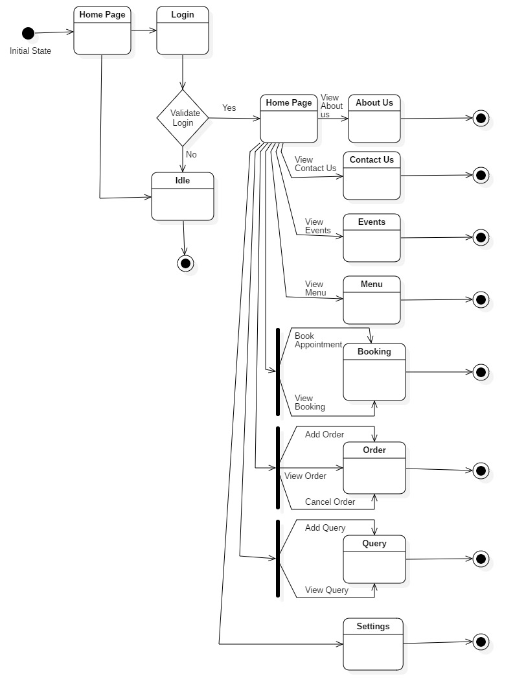

**Admin:**

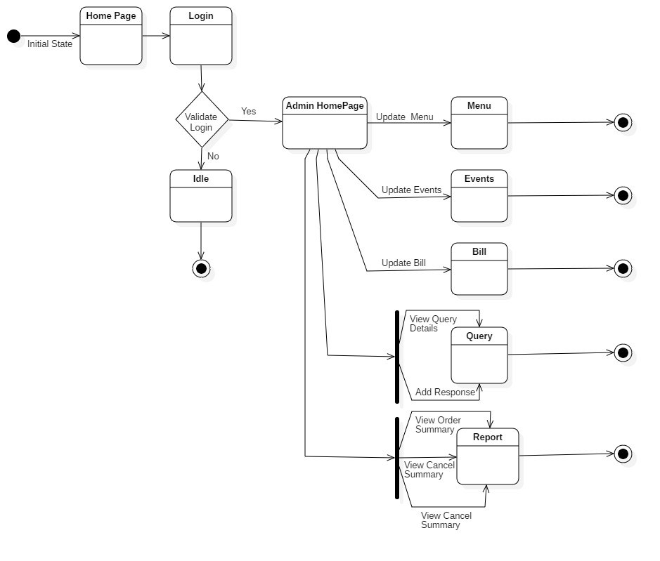

**Activity Diagram**

**Visitor:**

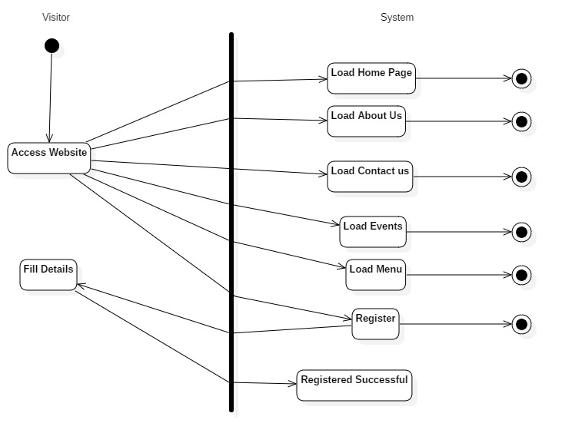

**Customer:**

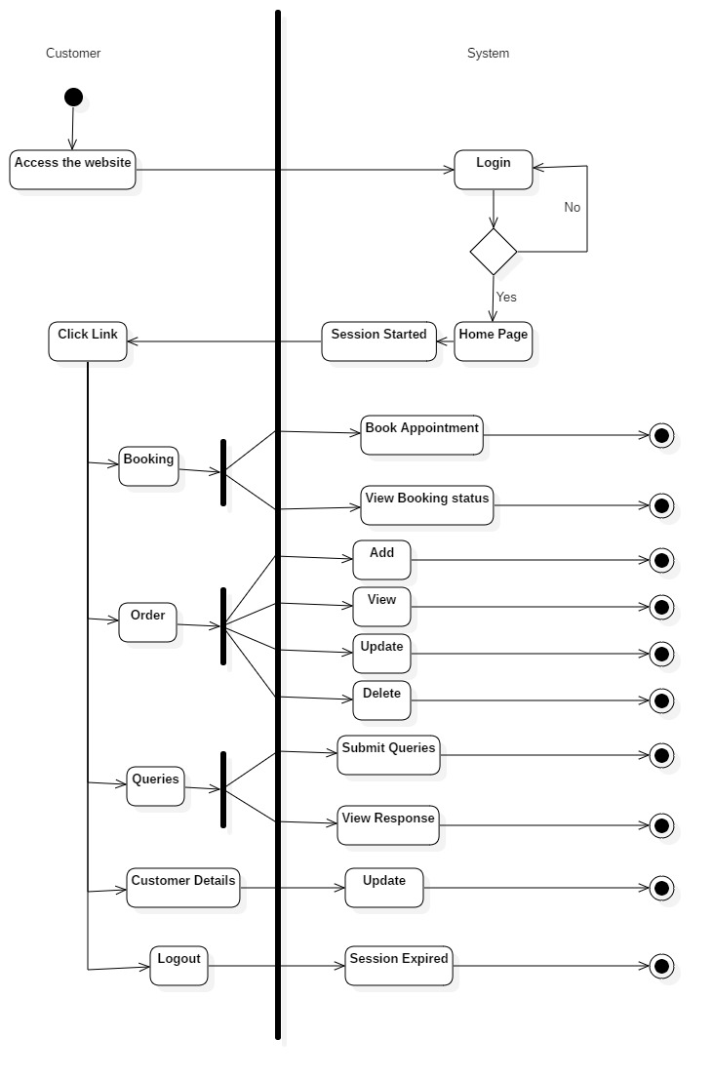

**Admin:**

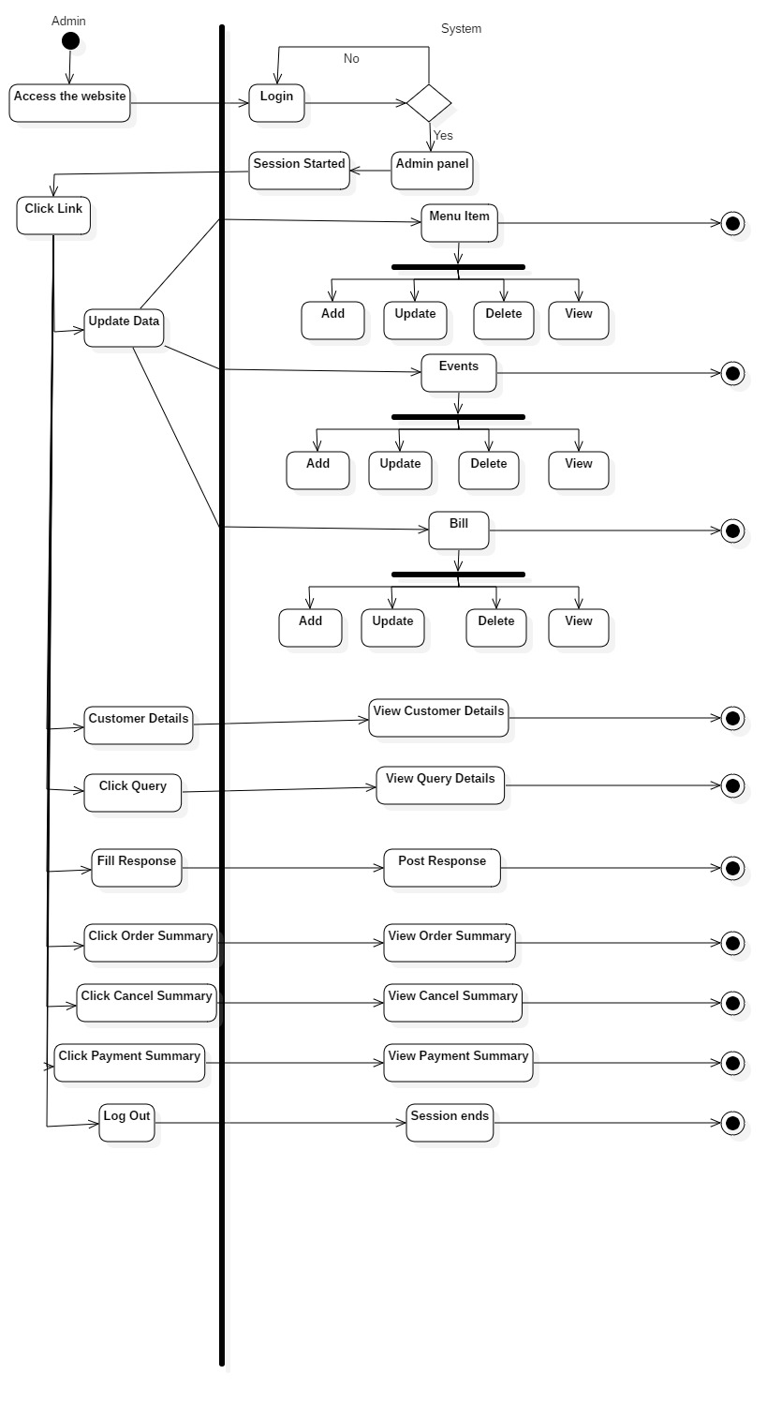

**Component Diagram**

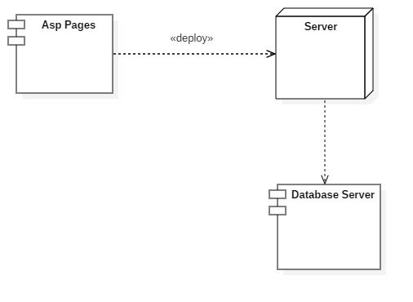

**Deployment Diagram**

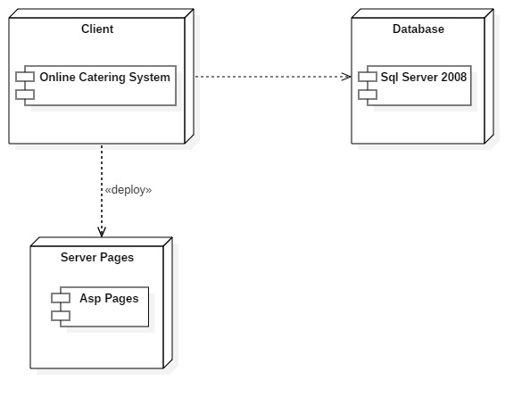

**Package Diagram**

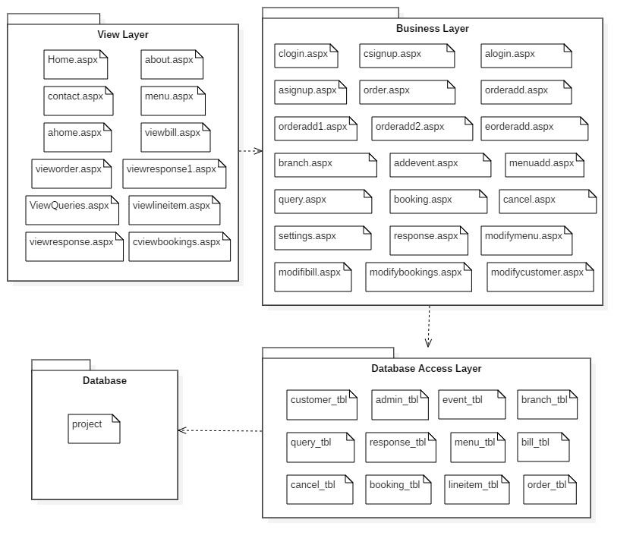

**System Coding**

**Validations**

For validation purpose in this Website it includes the following validations: -

1. During registration it checks that none of the field is vacant.

2. While entering the details following are validated: -

• Email id.

• For phone no. only number should be entered.

3. During login it checks whether such user exists from the database who had registered for the website.

4. Empty fields not allowed each field should contain values.

5. Registered user logs out from the session.

6. While entering the discount and tax it checks whether they are between 1 to 100.

|  |  |  |
| --- | --- | --- |
| **Name** | **Description** | **Properties** |
| RequiredFieldValidator | This validator does not allow users to leave a field blank if it is applied to a fieldset. It does not allow the form to be submitted if these fields are not filled | ControlToValidate  Error Message |
| RegularExpressionValidator | This validator allows the user to enter only valid email address, contact, number and name. | ControlToValidate  Error Message  Validation Expression |
| RangeValidator | This validator allows the user to enter only valid discount and tax i.e. between 1-100. | ControlToValidate  Error Message  MaximuValue  MinimumValue |

**Test Cases, Test Data and Test Result**

|  |  |  |  |  |  |  |  |  |  |
| --- | --- | --- | --- | --- | --- | --- | --- | --- | --- |
| **Test Case** | **Module Name** | **Form Name** | **Test Condition** | **Step Procedure** | **Input Test Data** | **Expected Output** | **Actual Output** | | **Result** |
| 01 | Login | clogin.aspx,alogin.aspx | Check login with valid input. | 1)Enter only email-id | e-mail:  [abc@gmail.com](mailto:abc@gmail.com) | Display Please enter the password | Display Please enter the password | Pass | |
|  |  |  |  | 2)Enter only paassword | Password: abc12345 | Display Please enter the e-mail | Display Please enter the e-mail | Pass | |
|  |  |  |  | Enter invalid email-id and password. | email:  [ab@gmail.com](mailto:ab@gmail.com)  Password: abc123 | Display Wrong e-mail or Password | Display Wrong e-mail or Password | Pass | |
| 03 | Registration | csignup.aspx,asignup.aspx | To check  Registration form with valid input | 1) Enter number in names field | Name::  121 | Display  Please enter character only. | Display  Please enter character only. | Pass | |
|  |  |  |  | 2)Enter only character in e-mail | E-mail : qq | Display  Invalid E-mail Id. | Display  Invalid E-mail Id. | Pass | |
|  |  |  |  | 3)Leave e-mail Id field blank | E-mail: | Display  Please enter e-mail. | Display  Please enter e-mail. | Pass | |
|  |  |  |  | 4)Enter invalid contact | Contact no:1234 | Display contact with 10 digits | Display contact with 10 digits | Pass | |

**Screen And Report Layouts**

**Home.aspx**

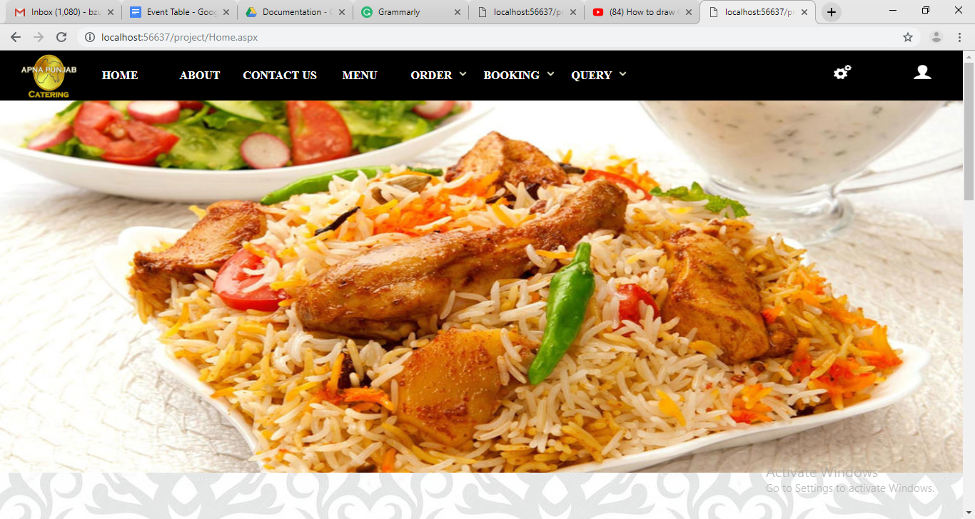

**About.aspx**

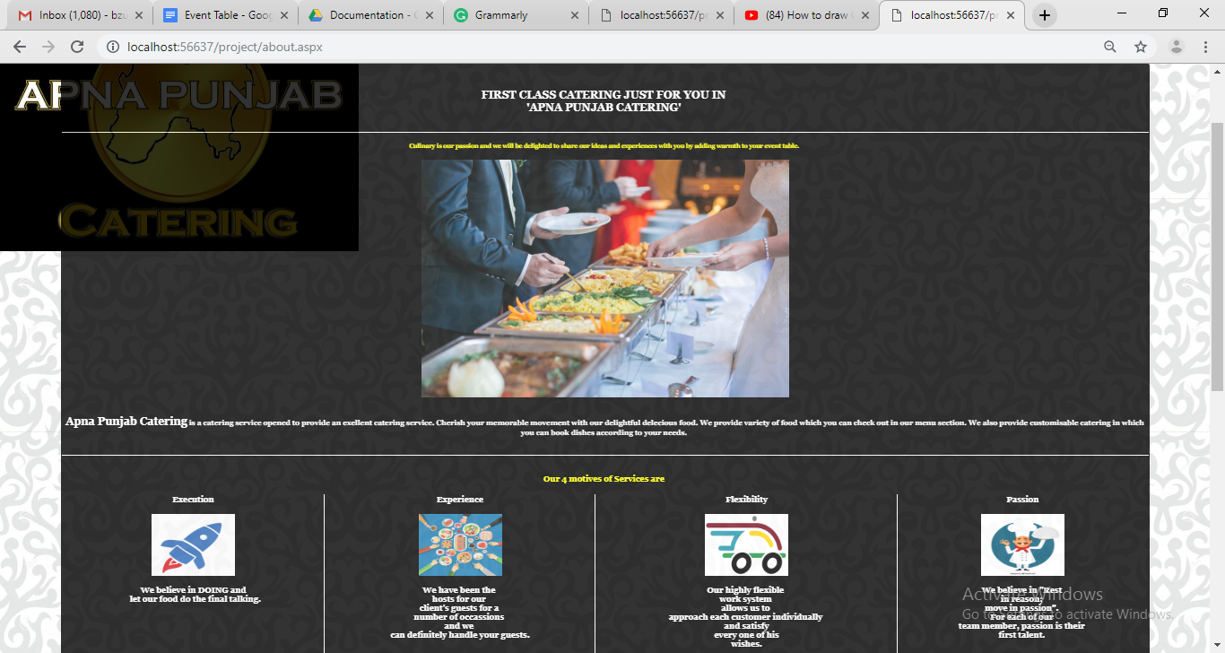

**Contact.aspx**

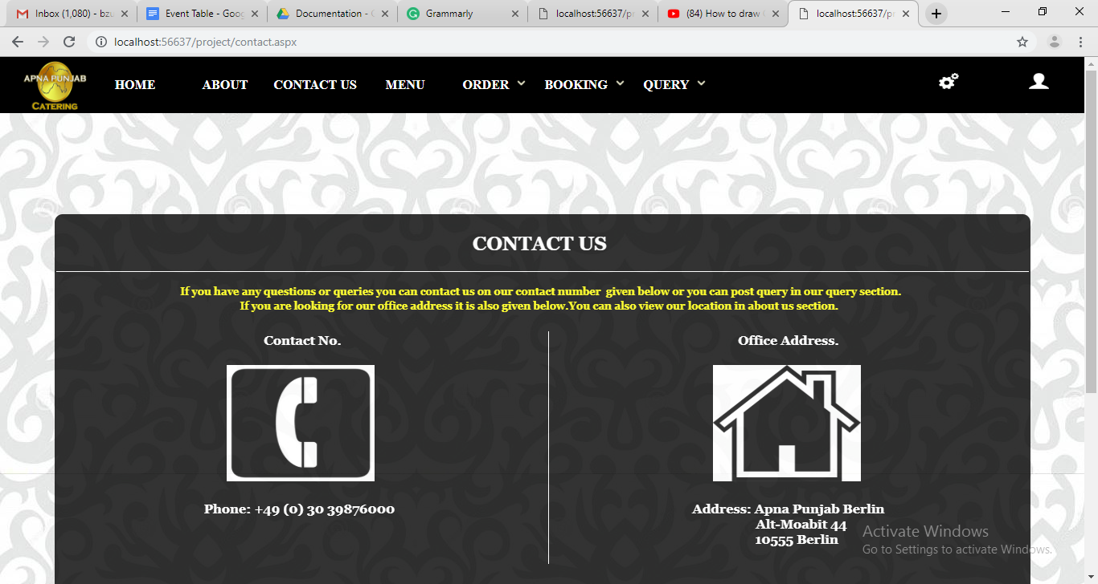

**menu.aspx**

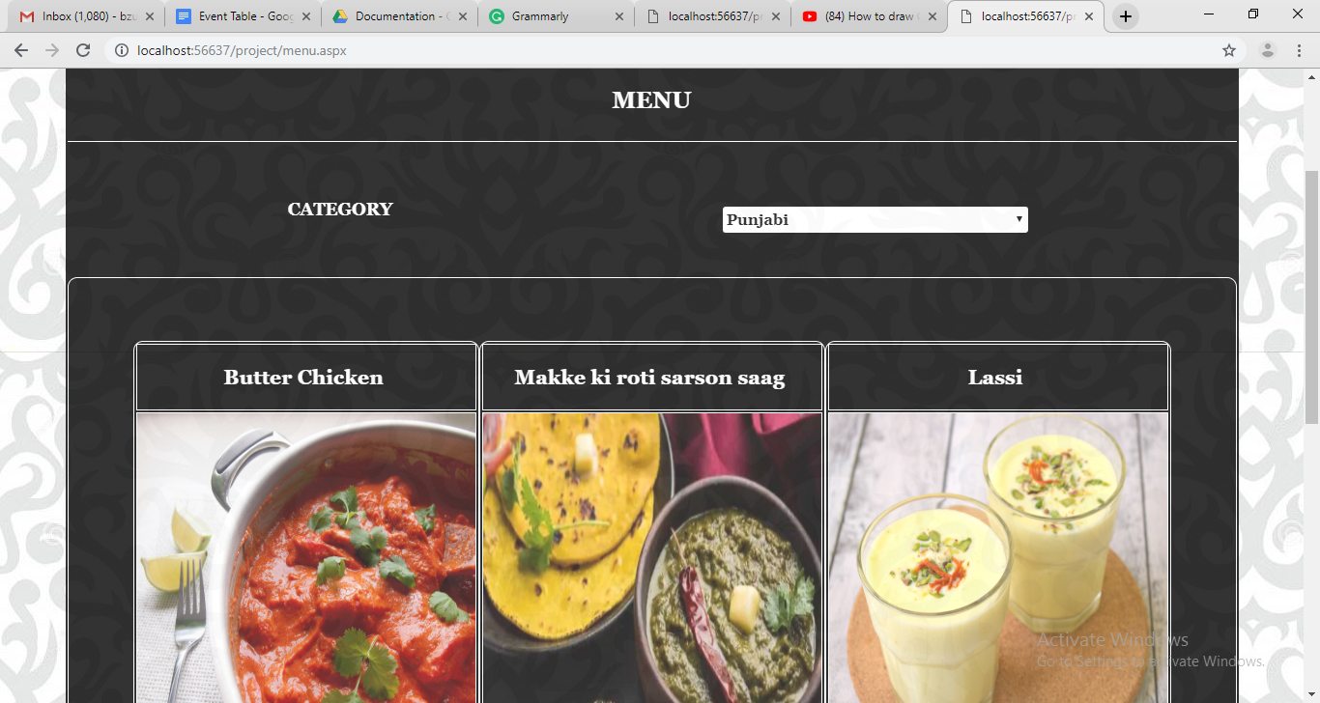

**booking.aspx**

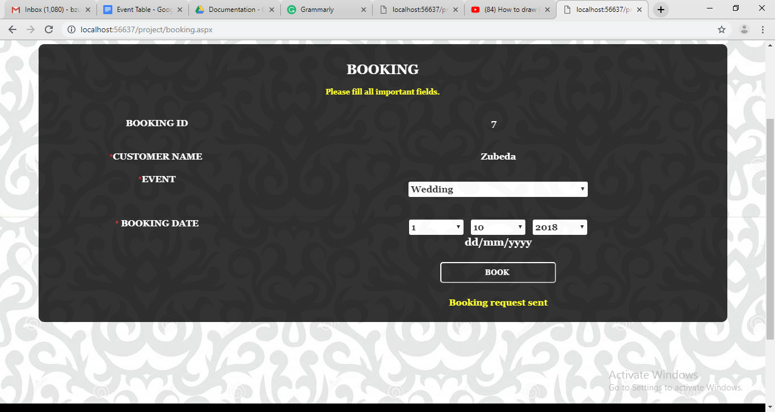

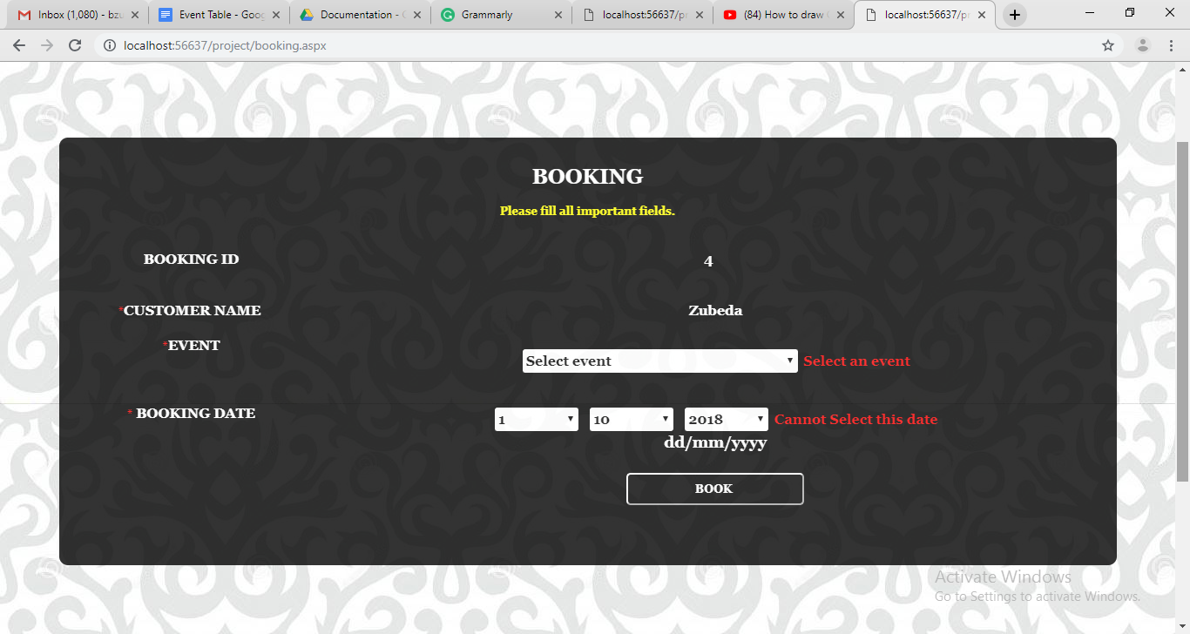**booking.aspx**

**query.aspx**

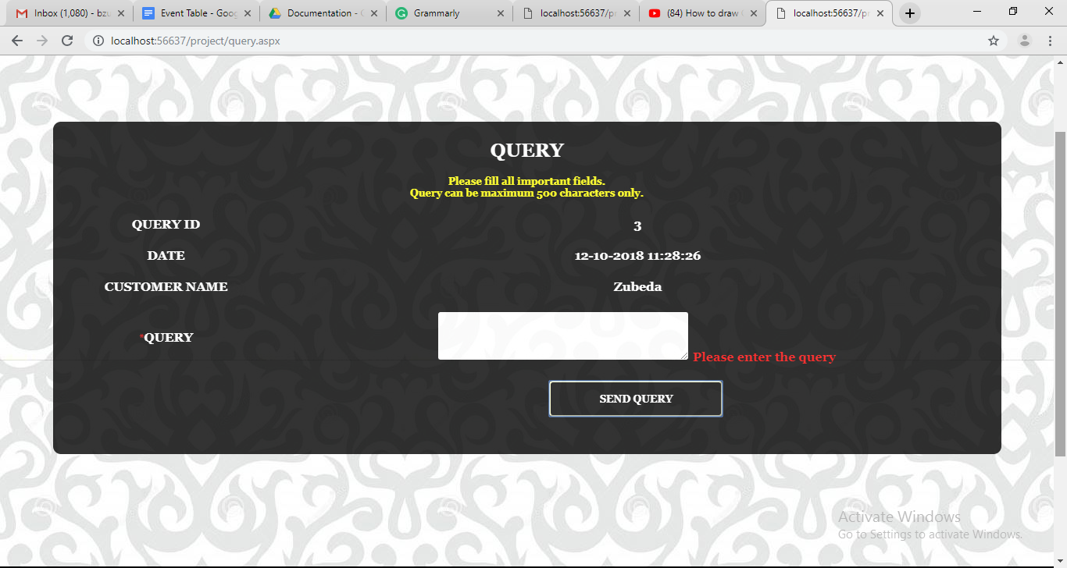**query.aspx**

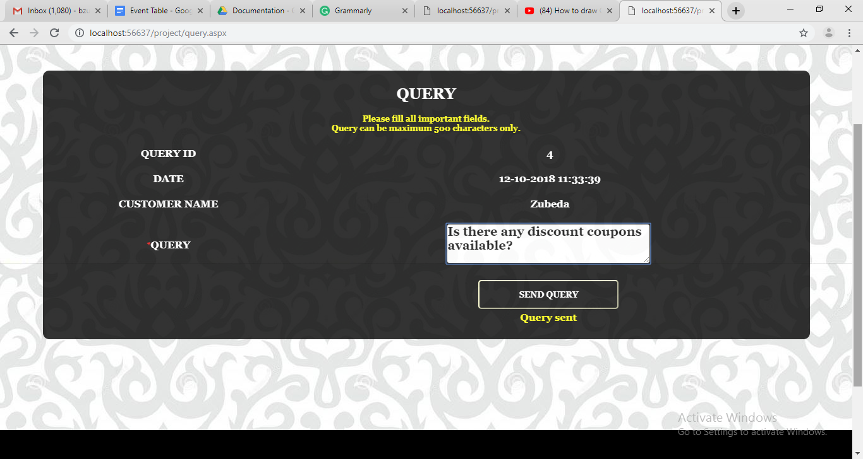

**clogin.aspx**

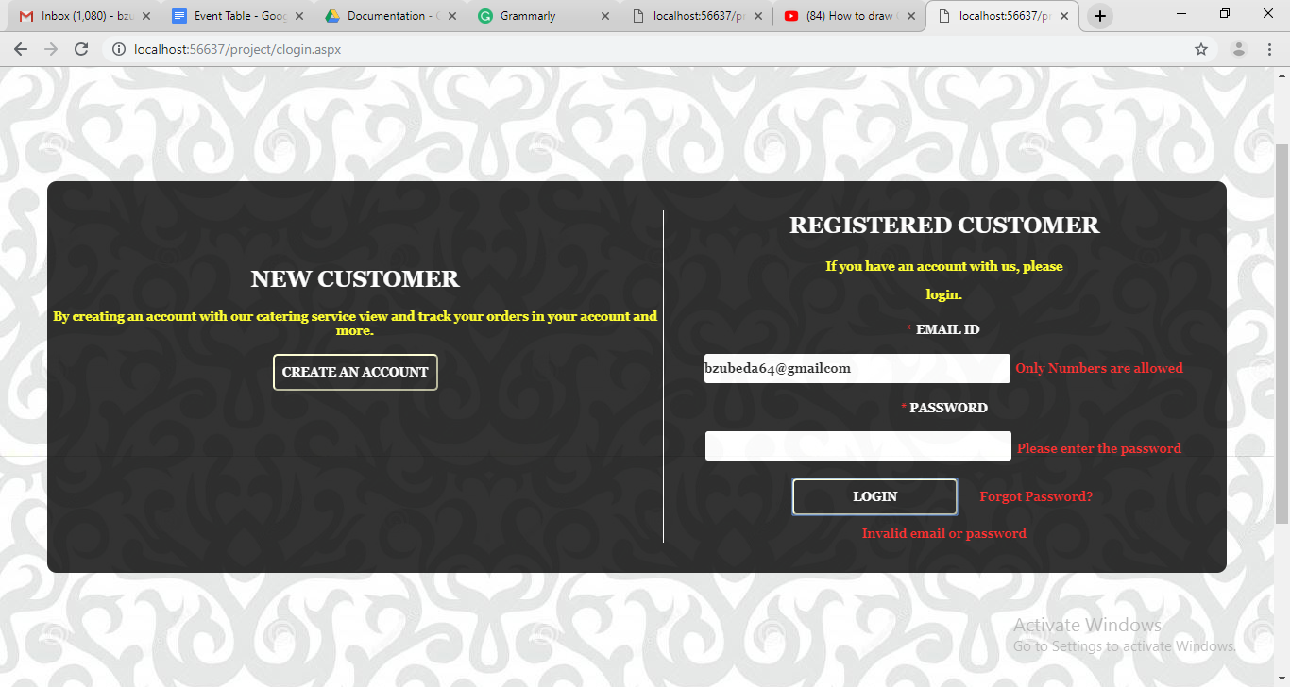

**clogin.aspx**

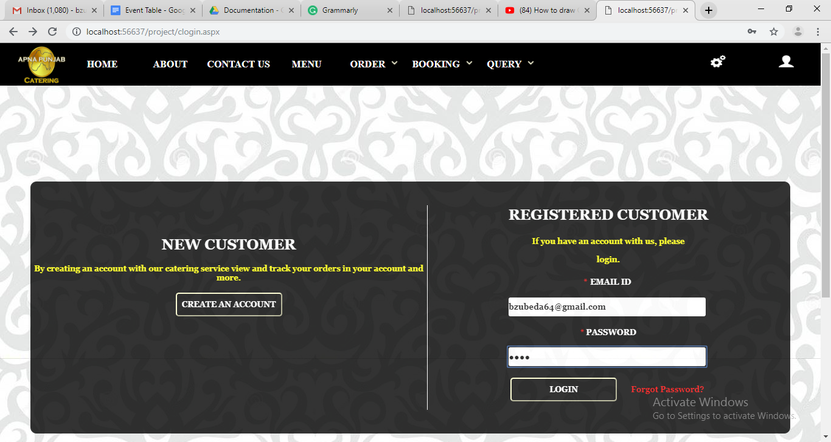

**settings.aspx**

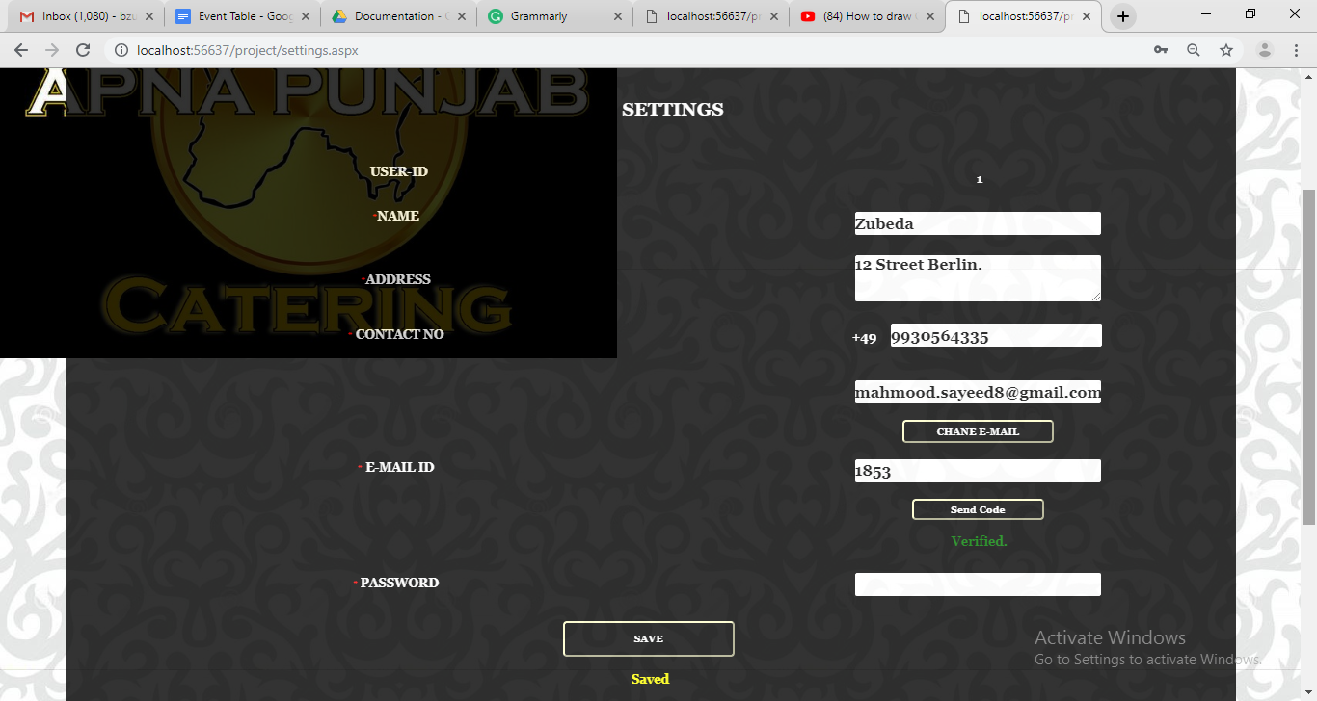

**alogin.aspx**

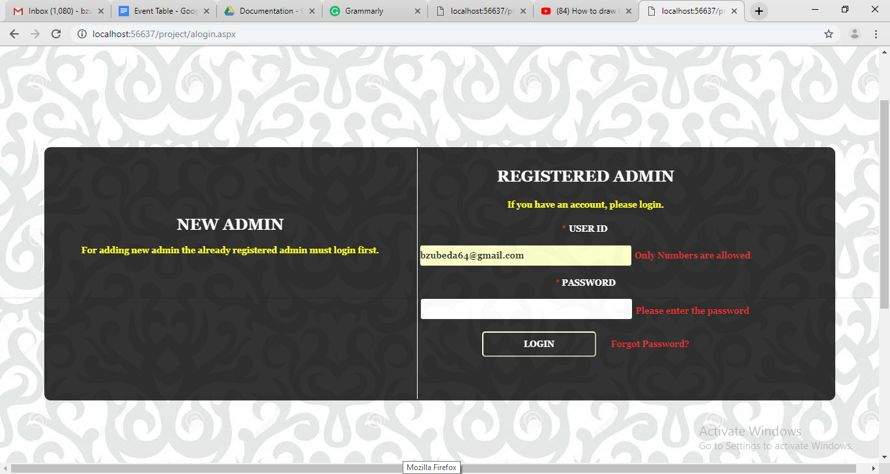

**alogin.aspx**

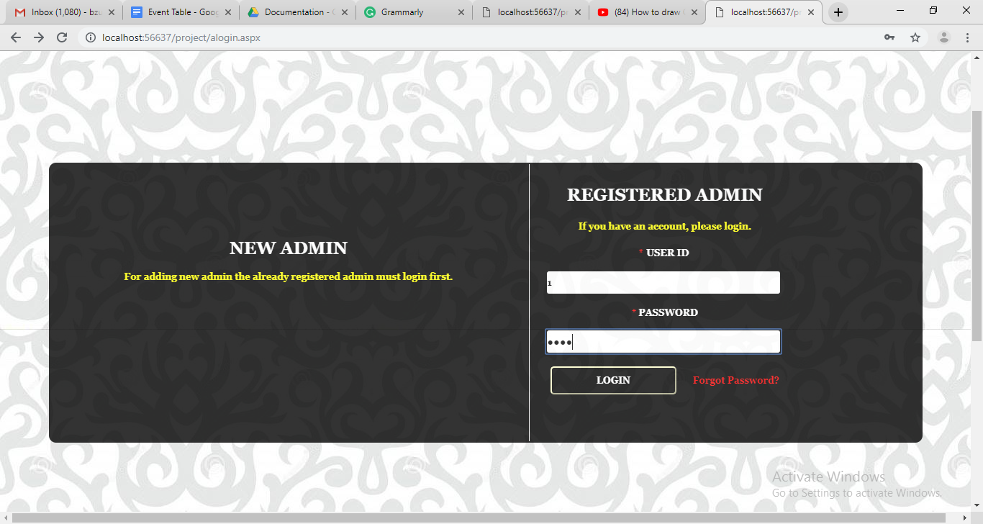

**asignup.aspx**

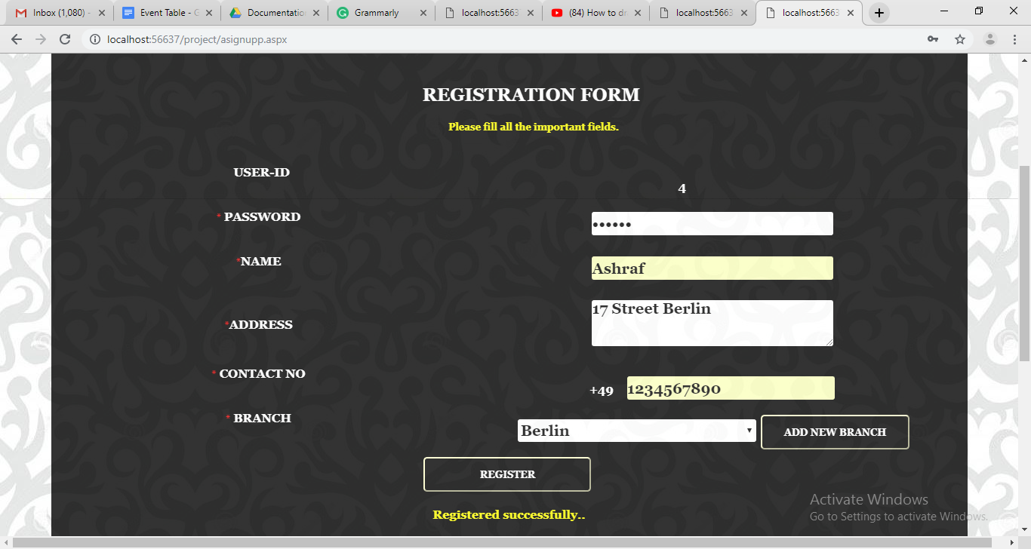

**meuadd.aspx**

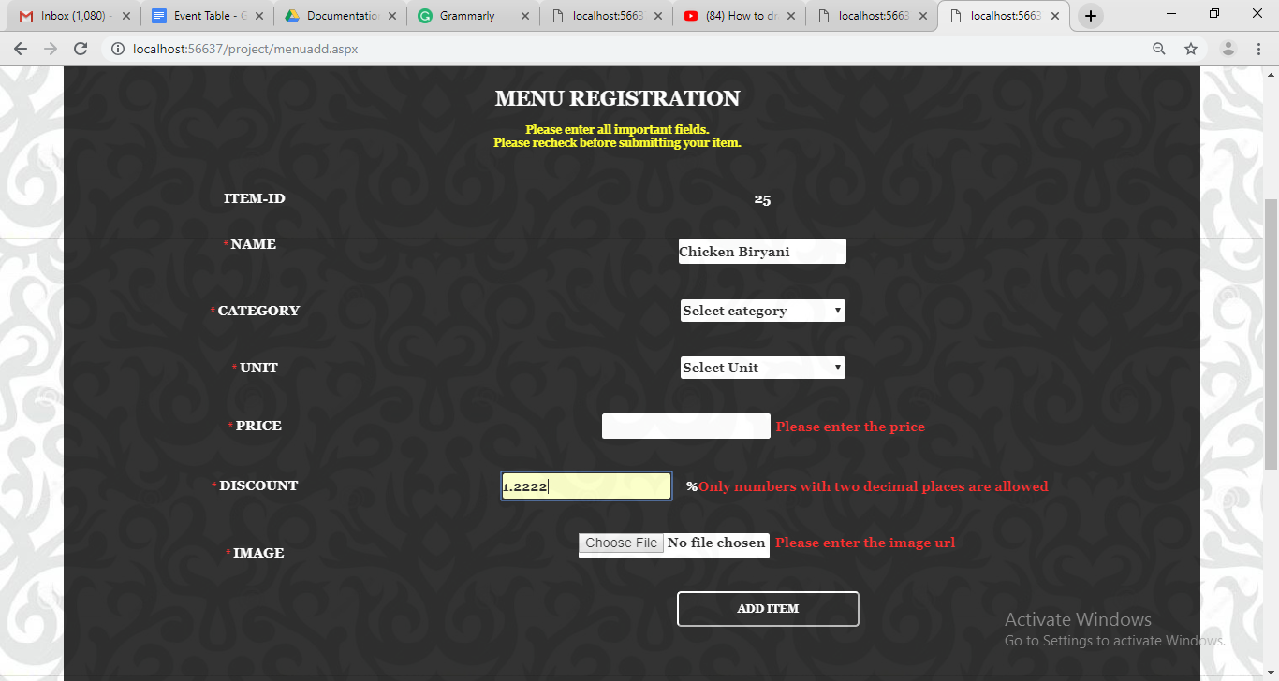

**meuadd.aspx**

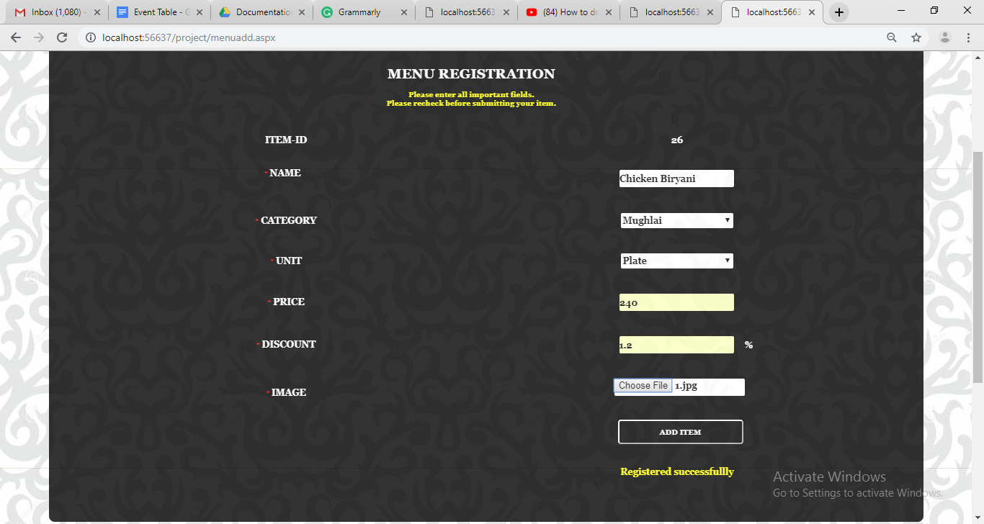

**modifymenu.aspx**

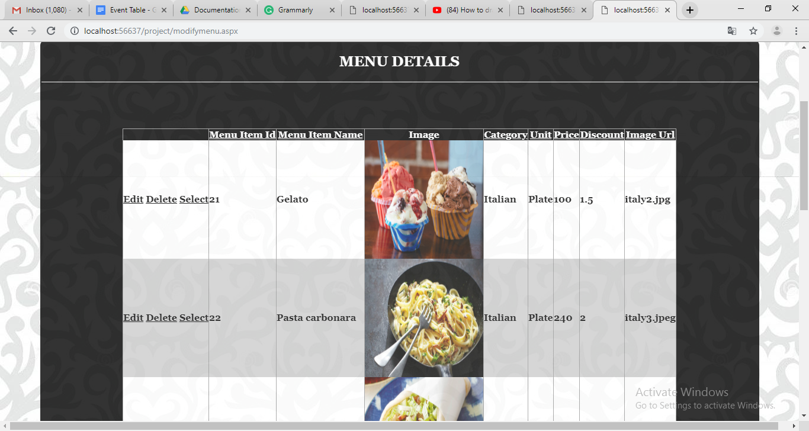

**order.aspx**

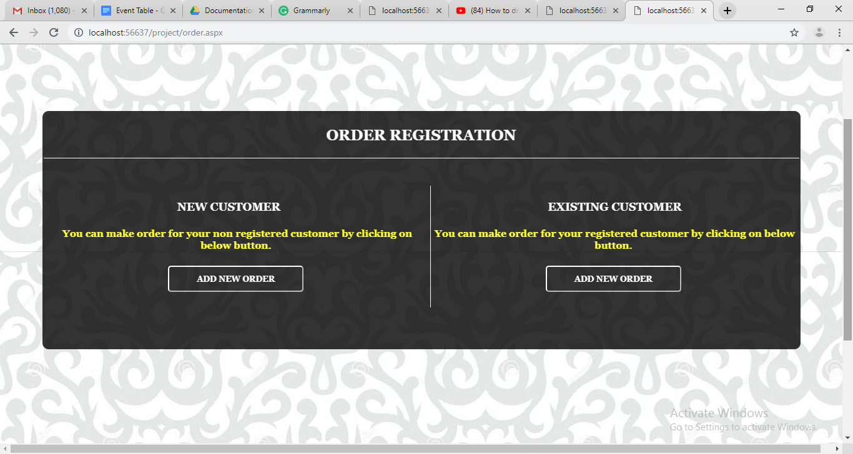

**Eorderadd.aspx**

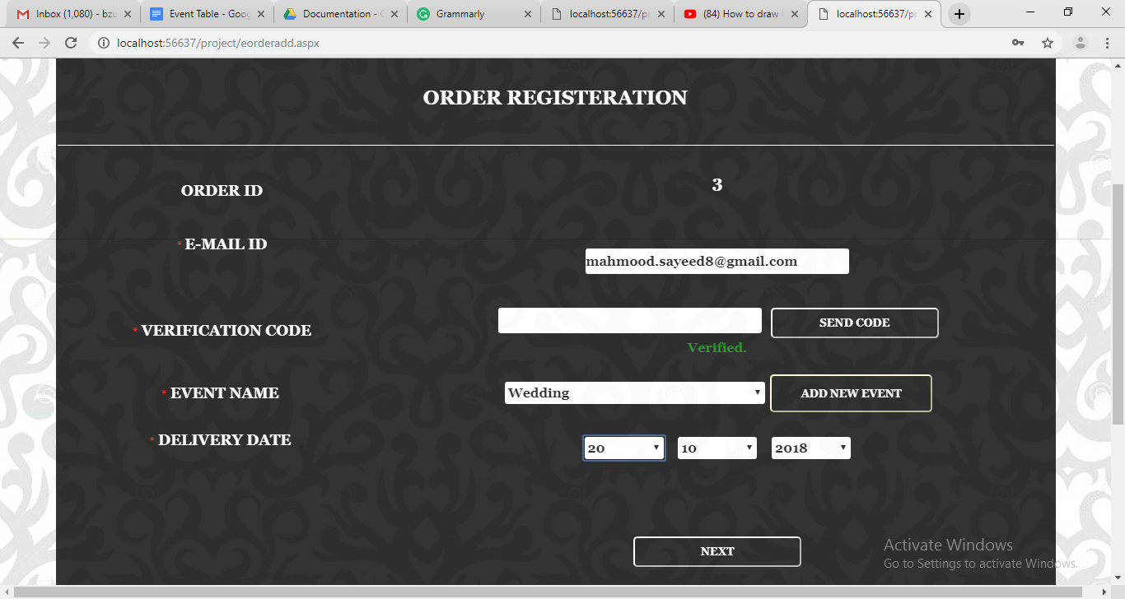

**oderadd1.aspx**

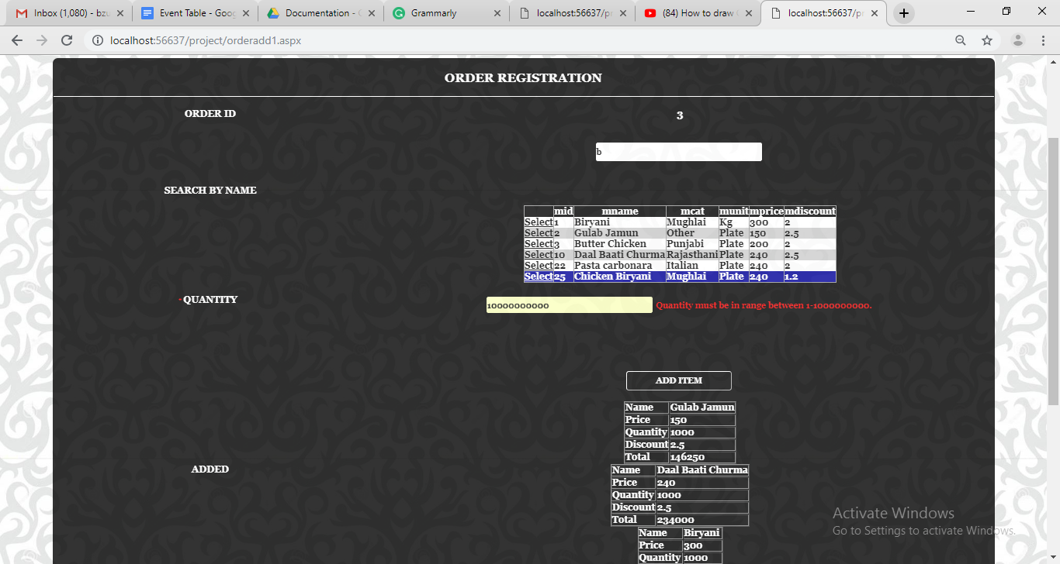

**orderadd1.aspx**

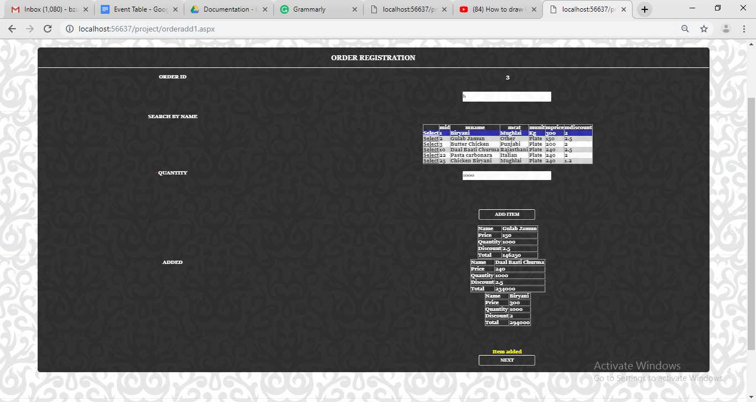

**oderadd2.aspx**

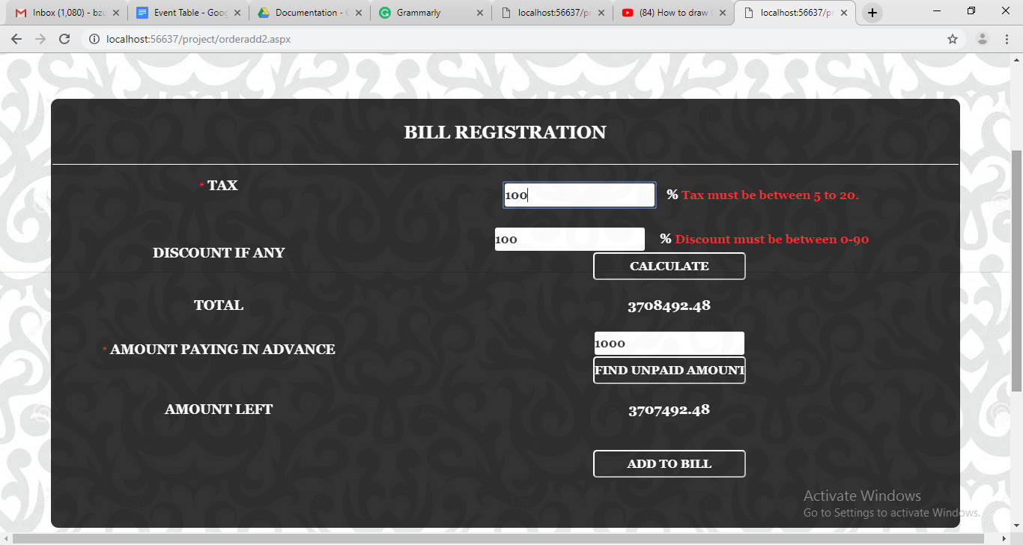

**oderadd2.aspx**

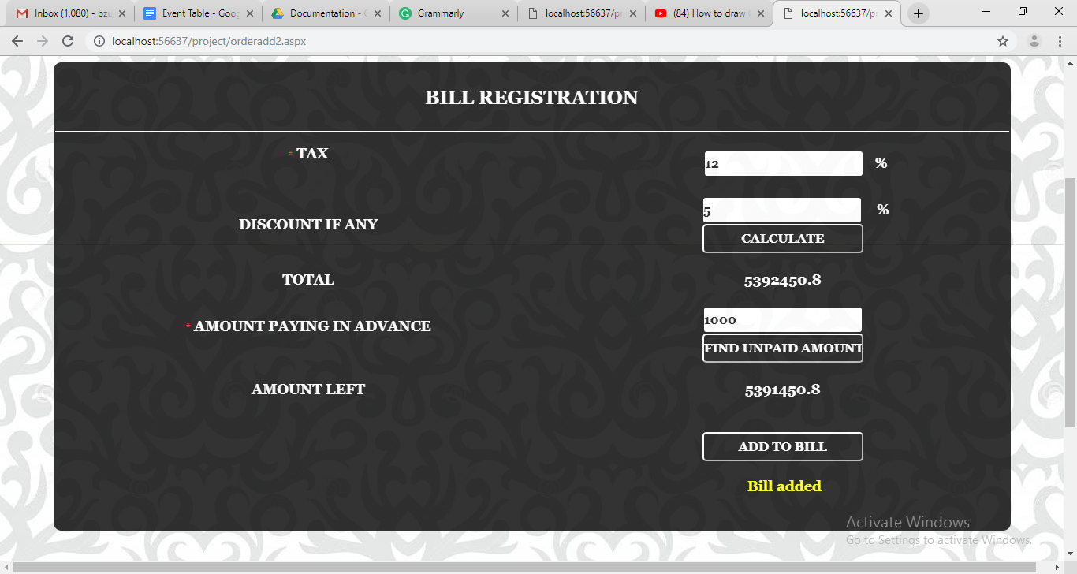

**response.aspx**

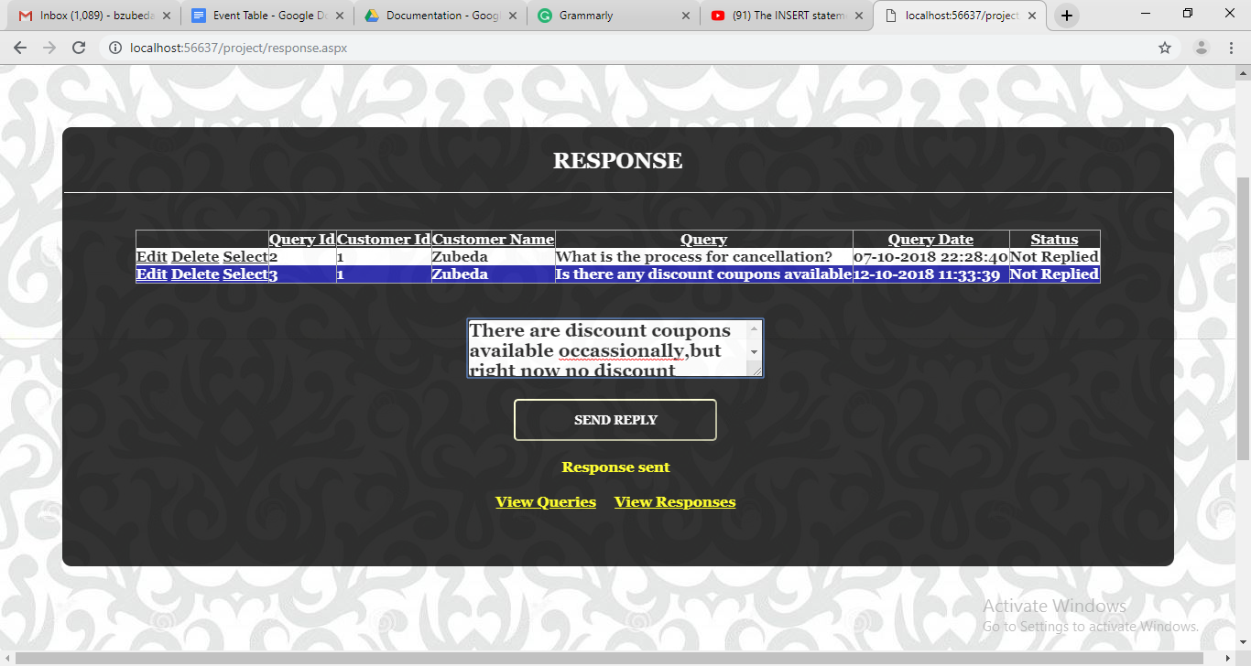

**deleteorder.aspx**

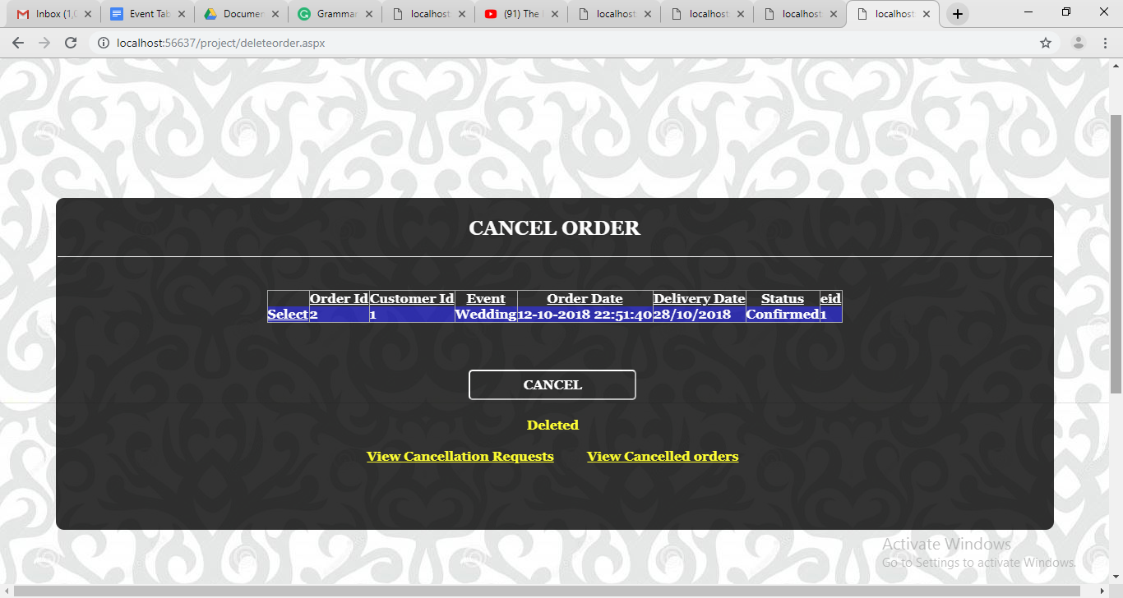

**System Implementation And Uploading**

Any website consists of mostly web page files and images. The process used to upload the files from a desktop PC to a web server space is called FTP (file transfer protocol). Essentially this is the opposite process from downloading files from the internet. The download process is all handled automatically by the web browsing software. Before uploading anything, one must find way to the hosting space. After signing up with the hosting company they provide information on how to upload web pages. The company provides with the details for the location of our space, a user ID and a password. To actually upload the files, one need to have an **FTP*client*. This is a software application designed to facilitate the *FTP* process. Within the FTP client one can set up the connection with the required information (the user ID and login from the hosting company). When this is set up for the site is done then drag and drop the files between folders on your PC using IE. The FTP client saves the details making it easier to do this on subsequent occasions.

1. Decide where you are going to put your pages.

2. Input the details of your account: username, password, hostname and URL.

3. Connect to the internet.

4. Open up as FTP program (like fetch-mac or ws-ftp-pc)

5. Put in the hostname of your website.

6. Put in your username

7. Put in your password

8. Connect to the site.

9. Highlights the files you would like on your website.

10. Click on the operation to transfer them to your website.

**FUTURE ENHANCEMENT**

* In Future I would like to make an android application for the store and have more relevant data for the same.
* I would like to like to add more Reports and Tracking System.
* I would like to put online ordering for customer.

**REFERNCES AND BIBLIOGRAPHY**

* [www.W3schools.com](http://www.W3schools.com)
* [www.tutorialspoint.com](http://www.tutorialspoint.com)
* [www.codeproject.com](http://www.codeproject.com)
* [www.c-sharpcorner.com](http://www.c-sharpcorner.com)